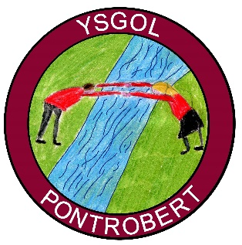
Grantiau 2020 Grants

Rydym wedi derbyn y grantiau canlynol am y flwyddyn 2020-21:
- Grant Amddifadedd Tlodi (PDG) £1,150,
- Grant Cynnydd Dysgu £2,445.23,
- Grant Gwella Addysg (EIG) £3,740.
Byddwn yn defnyddio y ddau grant cyntaf i gefnogi disgyblion sydd wedi cael eu heffeithio gan y clo mawr.
Byddwn yn defnyddio’r grant EIG i hyfforddi staff i wella medrau iaith a rhifedd y disgyblion a phrynu adnoddau i gefnogi’r dysgu yma.
__________________________

We have received the following grants for the year 2020-21:
- Pupil Deprivation Grant (PDG) £1,150,
- Accelerated Learning Grant £2,445.23,
- Educational Improvement Grant £3,740.
We will be using the first two grants to support pupils that have been affected by the lockdown.
We will be using the EIG grant to train staff to improve language and numeracy skills in pupils and to purchase resources to support this learning.

